<Shopaa>

Software Development Plan (Small Project)

Version <1.0>

Revision History

| **Date** | **Version** | **Description** | **Author** |
| --- | --- | --- | --- |
| 25/11/2022 | 1.0 | Change the project plan and Requirements Management | Nguyễn Thanh Phong |
|  |  |  |  |
|  |  |  |  |
|  |  |  |  |

Table of Contents

**1. Introduction** **4**

1.1 Purpose 4

1.2 Scope 4

1.3 Overview 4

**2. Project Overview** **4**

2.1 Project Purpose, Scope, and Objectives 4

2.2 Assumptions and Constraints 4

2.3 Project Deliverables 4

**3. Project Organization** **5**

3.1 Organizational Structure 5

3.2 Roles and Responsibilities 5

**4. Management Process** **6**

4.1 Project Estimates 6

4.2 Project Plan 6

4.2.1 Project Assignment 1 6

4.2.2 Project Assignment 2 8

4.2.3 Project Assignment 3 8

4.2.4 Project Assignment 4 9

4.2.5 Project Assignment 5 10

4.3 Project Monitoring and Control 11

4.3.1 Requirements Management 11

4.3.2 Reporting and Measurement 11

4.3.3 Risk Management 11

4.3.4 Configuration Management 12

Software Development Plan (Small Project)

# Introduction

The introduction of the **Software Development Plan** provides an overview of the entire document. It includes the purpose, scope, definitions, acronyms, abbreviations, references, and overview of this **Software Development Plan**

## Purpose

The purpose of the *Software Development Plan* is to gather all information necessary to control the project. It describes the approach to the development of the software and is the top-level plan generated and used by managers to direct the development effort.

The following people use the *Software Development Plan*:

* The **project manager** uses it to plan the project schedule and resource needs, and to track progress against the schedule.
* **Project team members** use it to understand what they need to do, when they need to do it, and what other activities they are dependent upon.

## Scope

This *Software Development Plan* describes the overall plan to be used by the Shopaa project, including deployment of the product. The details of the individual iterations will be described in the Iteration Plans.  
The plans as outlined in this document are based upon the product requirements as defined in the *Vision Document*.

## Overview

This *Software Development Plan* contains the following information:

Project Overview — provides a description of the project's purpose, scope, and objectives.  It also defines the deliverables that the project is expected to deliver.

Project Organization — describes the organizational structure of the project team.

# Project Overview

## Project Purpose, Scope, and Objectives

Purpose: Helping people that don't know how to cook local food can enjoy the food they want, provide a place where people can sell and enjoy local food that is not known to many people, make the typical local food accessible to everyone

The website can help users find, rate, buy, and sell the typical local foods

Additionally, can upgrade from buyer account

## Assumptions and Constraints

Project has fixed schedule of 12 weeks

The budget is zero if without publishing website

The budget is 5-10 millions VND if publishing a common website

Project has 4 people

## Project Deliverables

Deliverables for each project phase are identified in the Development Case. Deliverables are delivered towards the end of the iteration, as specified in section 4.2.4 Project Schedule

# Project Organization

## Organizational Structure

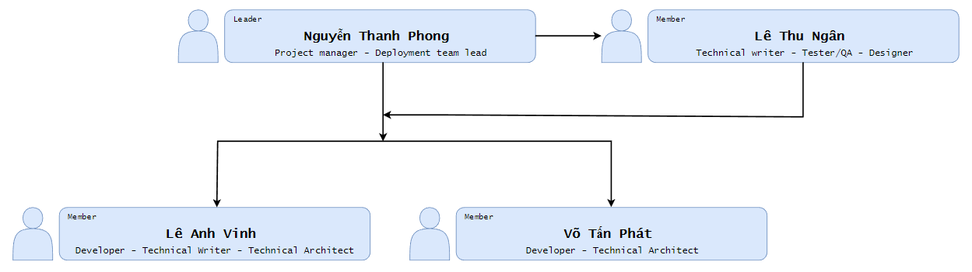

## Roles and Responsibilities

| **Role** | **Responsibility** |
| --- | --- |
| Project manager | - Responsible for managing the overall Project Management discipline. - Organizing and motivating a project team Monitor Project Progress and Set Deadlines  - Work with customers to define the requirements.  - Plan and develop the project idea |
| Technical Architect | - Determine organization needs and identify system specifications. - Analyze the needs of large systems and break them down into smaller manageable parts.  - Plan and design the structure of technology systems, discuss these with the client.  - Communicate system requirements to developers; explain system structure and provide assistance throughout the assembly process. |
| Deployment Team Lead | - Leading the team responsible for installation activities.  - Managing the resource of time  - Managing the deployment deliverables  - Keeping the team close-knit |
| Tester / Quality Assurance | - The Tester is responsible for executing testing, including test set-up and execution, evaluation of test execution and recovery from errors, and assessing the results of test and logging identified defects |
| Technical Writer | - Writes and edits technical documents including reference manuals and product manuals. Writes and edits procedural documentation such as user guides and manuals. Meets with engineers, programmers, and project managers to learn about specific products or processes. |
| Designer | - Develop illustrations, logos and other designs using software or by hand.  - Prepare rough drafts and present ideas.  - Conceptualize visuals based on requirements.  - Amend designs after feedback |
| Developer | - Researching, designing, implementing, and managing software programs  - Work with other developers to design algorithms and flowcharts Produce clean, efficient code based on specifications  - Troubleshoot, debug and upgrade existing software  - Configuration Manager Create technical documentation for reference and reporting |

# Management Process

## Project Estimates

Schedule for whole project

Start : 03/11/2022

End : 10/1/2022

Cost:

* 12 weeks - 2 days-off a week ~ 60 days
* 2 hours a day
* 4 members
* Total time 60*4*2= 480h
* Cost per hour: 5$/h

=> Estimated cost : 2400$

Circumstances in the project when re-estimation will occur:

* The estimated cost base on current requirement and can be re-estimate when customer need addition requirement
* Members delay
* Research time base on difficulty and each member

## Project Plan

We devise the whole project into 6 sprints, each sprint is 2 weeks ( seem as PA01 ) and 3 phases (Inception, Elaboration and Construction). Each phases have 2 sprints ( 4 weeks )

Inception :29/10/2022 to 12/11/2022

Elaboration :12/11/2022 to 9/12/2022

Construction :10/12/2022 to 10/1/2022

## Phase plan

| Phase | Inception | Elaboration | | Construction | |
| --- | --- | --- | --- | --- | --- |
| Sprint | Sprint 1/PA01 | Sprint 2/PA02 | Sprint 3/PA03 | Sprint 4/PA04 | Sprint 5/PA05 |
| Time | Start : 05/11/2022  End : 12/11/2022 | Start : 12/11/2022  End : 26/11/2022 | Start : 26/11/2022  End : 10/12/2022 | Start : 10/12/2022  End : 26/12/2022 | Start : 26/12/2022  End : 3/1/2023 |
| Tasks | _Define member role  _Plan for whole the project  _Learn basic code (html, css, js) | _Improve Plan and Vision  _Detail the product  _Present the Use-case model and Use-case specification.  _Learn code(html, css, js), learn about front-end | _Review Use-case model, Use-case specification  _Define software architecture  _Describe the architecture with components and relationships  _Analyze the front-end, back-end of the product | _Review SAD(PA03)  _Sketch the user interface for the system  _Code front-end from the sketch  _Code and test back-end | _Finish the product requirement  _Prepare a test plan, design test cases  _Execute test cases and summarize  _ Report test results.  _Finish all the project |

## Iteration Objectives

Inception :

* Have an overall view about the product, ,know what to do in the project

Elaboration :

* Have a detail view about the product and know what to implement it
* Have knowledge about web
* Presented a demo website

Construction :

* Complete the UI for the product
* Create a Release with over 70% completed
* Complete testing the product

## Releases

* 20/12/2022 : Demo 1 : Website UI
* 26/12/2022 : Demo 2 : Website with main function (...)
* 1/1/2023 : Demo 3: Test fix and complete back-end
* 10/1/2023 : Product : A completed Selling food Website

## Project Schedule

Note: : working time extended during sprint

: working time in sprint

: 1 day working time in sprint

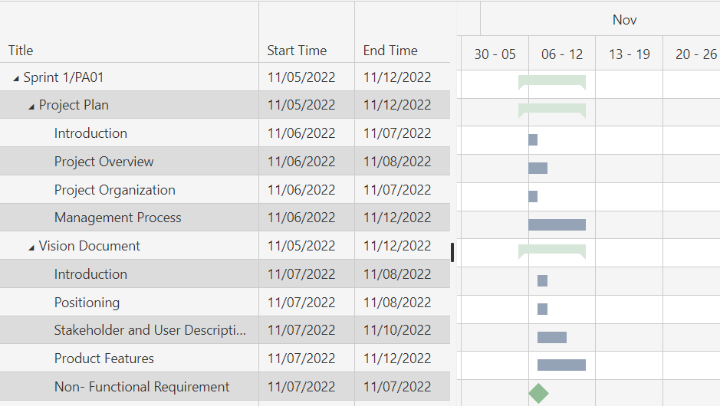

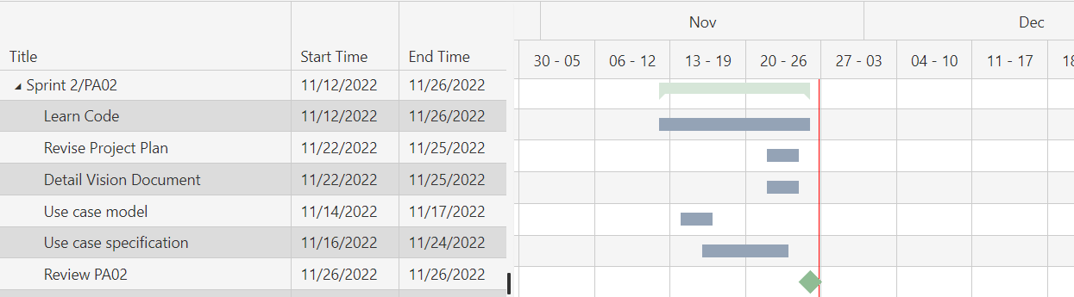

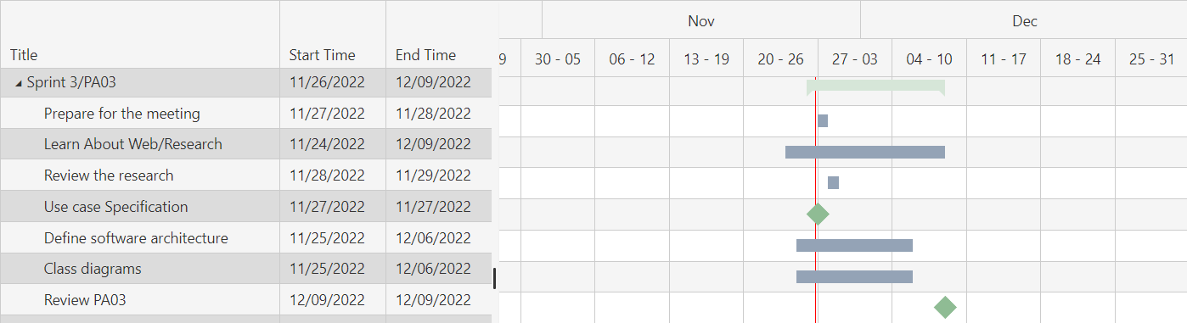

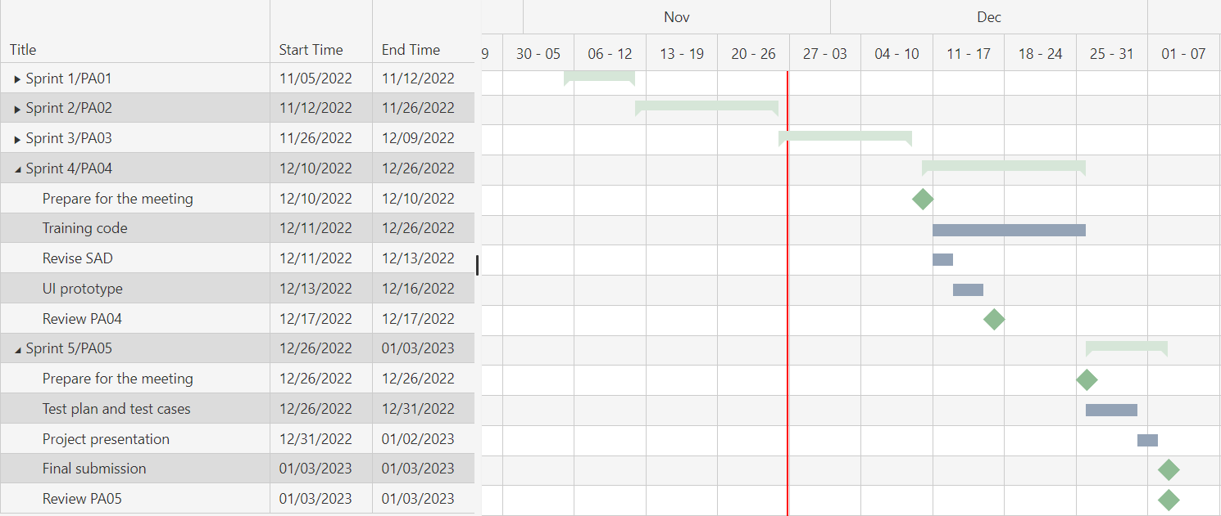

## Project Resourcing

Sprint 1/ PA01 : Inception phase (Start : 05/11/2022-End : 12/11/2022)

Task

1.Project plan:

Introduction :Ngân

Project Overview :Ngân

Project Organization :Phát

Management Process :Vinh, Phong

2.Vision Documents:

Introduction : Ngân

Positioning : Ngân

Stakeholder and user descriptions : Vinh, Phát

Product Overview and Features : All members

Non-Functional Requirement : Vinh, Phát

Sprint 2/ PA02 : Elaboration phase (Start : 12/11/2022-End : 26/11/2022)

Task:

Revised project plan :Phong

Detailed vision document :Phong, Ngân

Use-case model :Ngân, Vinh, Phát

Use-case specifications :All members

Learn code :All members

Sprint 3/ PA03 : Elaboration phase (Start : 26/11/2022-End : 10/12/2022)

Task:

Research and training code :All members

Use-case specification :Ngân, Vinh, Phát

Define software architecture :All members

Class diagrams :All members

Sprint 4/ PA04 : Construction phase(Start : 10/12/2022-End : 17/12/2022)

Task:

Training code :All members

Revise SAD :Phong,Ngân

UI prototype :Ngân,Phát,Vinh

Sprint 5/ PA05 : Construction phase(Start : 17/12/2022-End : 26/12/2022)

Task:

Test plan and test cases :All members

Project presentation :All members

Final submission :All members

## Project Monitoring and Control

### *Requirements Management*

We use these control mechanisms to collect and use for measuring, reporting, and controlling changes to the product requirements.

First we gather requirements from many sources. Second we Analyze the Requirements. Then we define the Requirements. After defining, we Prioritize the Requirements. Finally, we Validate & Maintain it

### *Reporting and Measurement*

*None*

### *Risk Management*

Risks will be identified in the Inception Phase using the steps identified in the RUP for Small Projects activity “Identify and Assess Risks”. Project risk is evaluated at least once per iteration and documented in this table. The risks of the greatest magnitude are listed first in the table.

| **Risk Ranking (High, Medium, Low)** | **Risk Description and Impact** | **Mitigation Strategy and/or Contingency Plan** |
| --- | --- | --- |
| High | The member lack of knowledge | The member can take part in courses, find online learning resources |
| High | The member can drop the project | The other members should know other people’s work to be able to fill the void of the person who withdrew the project |
| Medium | The schedule realistic may be wrong | The project manager need backup time |
| Medium | The member can work delay | The member should read PA in advance and ask the teacher for knowledge |

### Configuration Management

*None*